Karnataka Law Society’s

KLS GOGTE INSTITUTE OF TECHNOLOGY-590008

UDYAMBAG, BELAGAVI-59008

Department of Electrical & Electronics Engineering

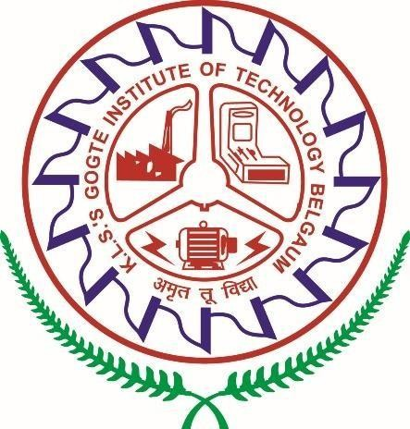

**SEMINAR REPORT - 2023-24 Subject: ENERGY AUDITING**

**Subject Code: 18EEOE763**

|  |  |  |  |
| --- | --- | --- | --- |
| **Seminar Title** | | Case Study on Energy audit and conservation Measures of University Hostels of Kurukshetra | |
| **Under the Guidance of** | | Prof. Ramesh G.B | |
| **Sl. No** | **USN** | **Name** | **Marks (Max. 20**  **Marks)** |
| 1 | 2GI20IS011 | Danesh Naik |  |
| 2 | 2GI20CS151 | Siddu Koligudd |  |
| 3 | 2GI20ME025 | Chetan kumar |  |
| 4 | 2GI20EC002 | Abdulla Jawad |  |

**Semester: 7th**

**Signature of Guide Signature of HOD**

KARNATAK LAW SOCIETY’S

## GOGTE INSTITUTE OF TECHNOLOGY

UDYAMBAG, BELAGAVI-590008

(An Autonomous Institution under Visvesvaraya Technological University, Belagavi)

**(APPROVED BY AICTE, NEW DELHI)**

## Department of “ELECTRICAL AND ELECTRONICS ENGINEERING”



**CERTIFICATE**

This is to certify that the course project entitled “**Case Study on Energy audit and conservation Measures of University Hostels of Kurukshetra**” is a Bonafede record of the Seminar work done by **Danesh Naik, Siddu Koligudd, Chetan Kumar,Abdulla Jawad** having **USN 2GI20IS011,2GI20CS151, 2GI20ME025,2GI20EC002** under my supervision and guidance, in partial fulfilment of the requirements for the Outcome Based Education Paradigm in EEE from Gogte Institute of Technology for the academic year 2023-2024.

Signature of the Faculty Member Signature of HOD

# ABSTRACT

Energy generation and use are the deciding factors for the economic growth of a developing country. Energy conservation is the best way to fulfill the rapidly raising energy demands in India. the detailed analysis of an organization is done and the areas are then identified where the energy conservation possibilities can be identified. In this case study, an analysis was carried out on the energy consumption of various electrical appliances in hostels of a university campus. The observations show that by minimizing the wastage of energy by electrical appliances such as fans, tube lights, refrigerators and geysers when not in use, around Rs 4.5lakh/ Remarkable electricity savings can also be achieved by replacing the existing electrical appliances with energy efficient appliances.

# Introduction

One of the major factors that plays an important role for the development in developing countries is the total power availability. The total installed power capacity India as on Sept. 2017 is 3,29,298 MW out of which 2, 19,450 MW is generated from thermal power stations, 44,765 MW from Hydro, 6780MW from Nuclear and 58303 MW from renewable. In India, during 2015-16, 1075 KWh was the per capita total consumption of electricity. Energy consumption is increasing with the rise in population so India’s power system needs to become for times in size by 2040 to meet the required demand of electricity which is achieved by rising incomes and new connections to the grid.

Due to continuous rise in energy cost, energy conservation is very essential therefore in order to conserve energy all possible methods should be identified and applied to conserve energy and decrease the energy cost. Reducing energy consumption by means of preventing energy losses can be a good solution for energy conservation. Use of electricity is one of the major contributors of energy consumption in our daily life. Proper use and management of electricity usage is essential to conserve energy. Hence Energy Audit of various Institutes, buildings or industries helps to inspect the methods of consumption and to find out the areas where wastage of electricity takes place so that required methods electricity can be applied to control the energy losses. Energy audit of a building can be a preliminary walk-through to a detailed analysis of audit the Energy Conservation Act, 2001, Energy Audit is defined as "the verification, monitoring and analysis of energy use.

including submission of technical report containing recommendations for improving energy efficiency with cost benefit analysis and an action plan to reduce energy consumption . Energy audit is an efficient tool not only to identify the total energy consumption but to find out different possible ways for conserving energy in a building or a system.

Hence in the present case study a walk-through energy audit of hostels of University Campus was conducted so as to identify reasons for energy losses and also to find methods for saving that energy in the hostel campus.

# Methodology:

1. Study area: This study was carried out at girls’ hostel premises of Kurukshetra University. There are 12 girls’ hostels in the University campus with the capacity to accommodate 3000 girls. The Preliminary Audit or Walk through energy audit was conducted in the hostels in order to determine how and where energy is used and how the energy savings can be done.
2. Data collection task was done at all the hostels of Kurukshetra University and other supporting entities such as library, computer facility etc. for 2 years 2012 and 2013 in order to get information regarding the power consumption pattern of all the hostels of Kurukshetra University in detail.
3. Analyze Energy Consumption Data: Analyze the collected energy consumption data to identify trends, patterns, and anomalies. Determine the major contributors to energy consumption and potential areas for significant savings.
4. Evaluate Energy Efficiency Opportunities: Assess the feasibility and potential impact of various energy conservation measures, including lighting upgrades, HVAC system optimizations, appliance replacements, and behavioral changes. Prioritize measures based on their cost-effectiveness and energy savings potential.
5. Develop Energy Conservation Plan: Formulate a comprehensive energy conservation plan that outlines the recommended measures, implementation timelines, estimated costs, and expected energy savings. Include detailed specifications, implementation procedures, and cost- benefits.
6. Present Findings and Recommendations: Present the findings of the energy audit and recommendations to the university administration, hostel staff, and student occupants. Explain the benefits of energy conservation measures and encourage participation in the implementation process.
7. Implement Energy Conservation Measures: Prioritize and implement the recommended energy conservation measures, following the detailed specifications and implementation procedures outlined in the energy conservation plan.
8. Monitor Energy Savings: Continuously monitor energy consumption data after the implementation of energy conservation measures to track progress, evaluate effectiveness, and identify areas for further improvement.
9. The complete information regarding the appliances usage were obtained from the related resource persons e.g. Wardens, Supervisors, Electricians, Attendants (hostels). Overall information regarding the different electrical appliances of all the hostels of Kurukshetra University is given in Table -1.

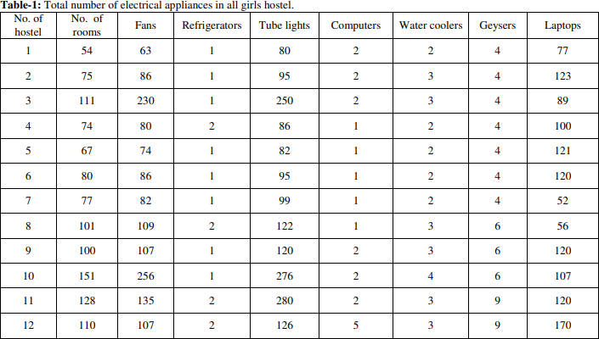

# Results and discussion:

The consumption of electricity in University hostel is mainly for purpose of lighting, fans, refrigerators and also for water purification, computer use etc. The maximum electricity consumption was found in the month of May (61194 KWh) and minimum in October (31193KWh) in year 2012 while in 2013 the maximum electricity consumption was in June (54997 KWh) and minimum in July (28968KWh).

Equipment wise analysis of overall hostel electricity consumption is given in Figure-1, which shows that maximum energy consumption is by fans followed by geysers, refrigerators, water coolers, tube lights, laptops and computers. In terms of energy savings it was observed that energy losses occur in the area where there is continuous use of fans, lights, computer system, and geysers even when not required.

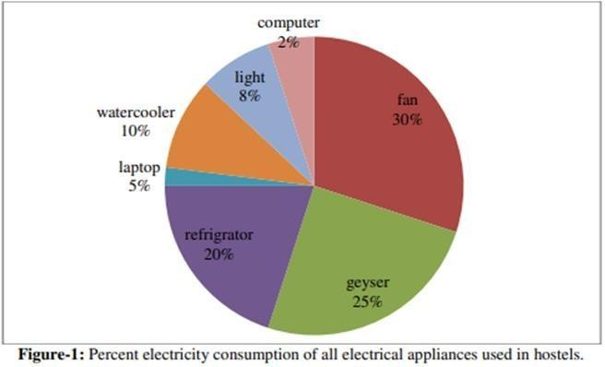

# Energy Saving Measures:

Calculation of electricity consumption in hostels:

Fans: Audit observations: It was found that total 166404units were consumed by fans when the usage time for a day was 8hours. However, when the usage time was reduced by 1 hour savings of 20800.5 units were observed. In terms of money around 1 lakh rupees can be saved.

Wattage of existing fan=60 watt = 60/1000=0.06KW, Usage of Fan=8hr=0.06×8=0.48 units or KWh (1KWh=1unit), Units consumed by total numbers of fans in hostels=1415×0.48=679.2 units, In year=679.2×245=166404 units, Cost of one unit= Rs. 6.2. Total cost for 166404 units (per year) =166404 units×6.2 = Rs.1031704.8.

Recommended energy saving measures To minimize losses if fans are switched off for at least 1hr. For one hour no. of units consumed= 0.06KWh Total units consumed by total fans in hostels =1415=1415 × 0.06 = 84.9 units Total saving of units after reduction of fan usage time for one year 84.9×245 = 20800.5 units Total monetary savings =Rs. 20800.5×6.2=Rs.128963.

If 60watt fan is replaced by Orient 48W energy Power drawn by existing single fan= 60W Power drawn by energy efficient single fan=48W Difference=12W Total no. of fans =1415 Savings = 1415×12÷100=16.98KW In year- 8×245×16.98=33280KWh or units Cost of one unit=Rs.6.2 Monetary savings= 33280×6.2=Rs.206336.

Price difference between the old fan and energy efficient fan is approx. Rs.400 Cost involved for replacing all the existing fans =Rs.566000 Payback period is 566000×12÷206336=32 months=2years and 8 months.

Tube light: Audit observations: In case of tube light consumed units was 174864.2 when tube light working hours were 10. However 17486.42 units were saved when their usage time was reduced by 1 hour. By doing so approximately 1 lakh rupees saving can be achieved. Total unit consumption by tube light in one year=479.08 x 365 = 174864.2 units Total cost for 174864.2×6.2= Rs.1084158.04.

Recommended energy saving measures Total saving of units after reduction of light usage time=17486.42 units Total monetary saving of Rs =Rs.108415.804 .

If existing 28watt tube light is replaced by T5 LED light of 22W Power drawn by existing single tube light=28 Power drawn by energy efficient single tube light =22 Savings=6 W Total no. of tube lights =1711 Savings- 1711×6÷1000= 10.266 KW In year= 10×365×10.266= 37470.9KWH or units.

Price difference between the old one and new T5 LED tube light is approx. Rs 300 Cost involved for replacing all the existing tubes=Rs.513300 Payback period is 513300×12/232319.58=26 months=2year and 2 months.

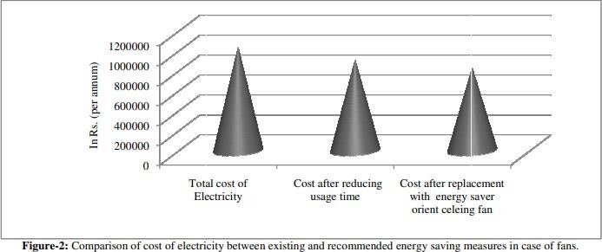

Refrigerator: Audit observation: 280320 units were if the duration of usage of refrigerator was 24 hrs when this time is reduced by 1 hour 11680 units were saved which is equal to saving of around 72 thousand rupees. Total unit consumption by refrigerator in one year=768 x 365 = 280320 units Now cost for 2803202 units is = Rs.1737984 .

Recommended energy saving measures Total saving of units after reduction of refrigerator usage time =11680 units Total monetary saving = Rs.72416.

Replacement of old refrigerator with Bee star rated refrigerator having power wattage between 100-400W

Power drawn by existing refrigerator=2000W Power drawn by energy efficient single refrigerator=400W Savings= 1600W Total no. of refrigerator =16 Savings = 16×1600/1000= 25.6KW In year-24×365×25.6=224256 KWH Cost of one unit=6.2 Savings=Rs.1390387.2 Price difference is approx. Rs. 20, 000 Cost involved for replacing all the existing refrigerators

= 20,000×16= Rs. 3, 20,000 Payback period is=3, 20,000×12÷1390387= Around 3 months

Computers: Audit observation: If computers were used for 5 hours in a day then consumption of 10037.5 units was observed. If this usage time is reduced by 1 hour, 2007.5 units can be saved which amounts to savings of approximately 12 thousand rupees.

Total unit consumption by computer in one year= 10037.5 units Cost for 10037.5 units is = Rs.62232.5 Total saving of unit after reduction of computer usage time = 2007.5 units Total monetary saving of Rs = Rs.12446.5

Other method to save electricity in computers is to shut down the system properly when system is not in use instead of put it on sleep mode.

Geyser: Audit observation: When the usage time of geyser for a day is 8 hours then 184320 units are consumed but if this time is reduced by 1 hour, saving of 23040 units can be achieved

i.e. saving of approximately Rs 1.25 lakh rupees. Total unit consumption by geyser in six month = 1024×180=184320 units Cost for 184320 units = Rs 1142784

Total saving of units after reduction of geyser usage time= 23040 units Total monetary saving

= Rs.142848 If normal water heater is replaced by energy efficient Heat pump water (R O Smith, Bajaj etc) of 50 ltr water capacity Heating units = Total volume of water taken × Difference in temperature of cold and hot water × 0.0012 .

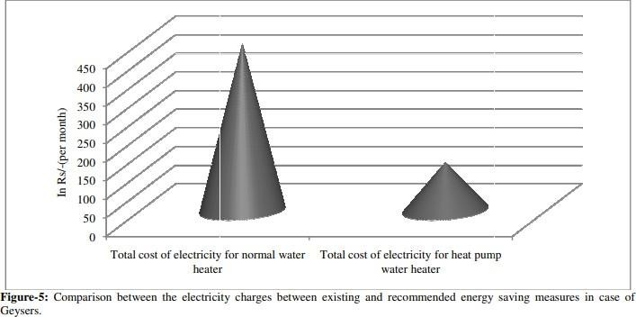

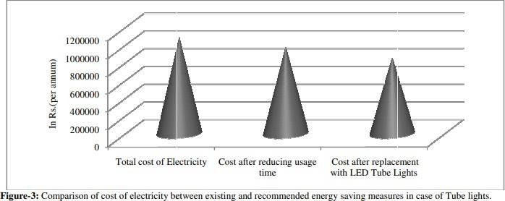

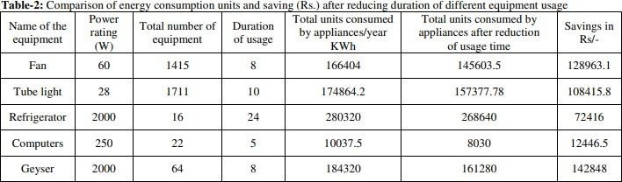

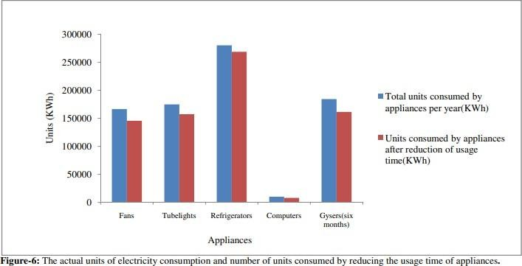

# Conclusion:

The energy production (supply) and consumption (demand) pattern of a country not only determines whether a country is developed or developing, it also leads to some major environmental issues like depletion of natural resources, pollution/carbon emissions, desertification etc. The major reasons for increase in energy demand are rapid rise in population, luxurious style of living, improper use of electrical equipment, inadequate knowledge etc. Energy audit lowers down the power demand by conserving energy which can be achieved by implementing the suggested changes in different sectors. In this case of energy audit of hostels premises study total energy consumption of all appliances and energy conservation after suggesting energy saving measures of reducing the usage duration of appliances was estimated by energy audit. By applying the energy saving method of reducing the usage time of appliances total saving is estimated to be Rs. 4, 65,089/- per annum. Remarkable energy savings can be done by replacing the existing electrical appliances with energy efficient appliances i.e. approximately 20 lakh rupees. By adopting proper measures as suggested in the study, i.e. reducing usage time, replacements, and by making the people aware about the significance of energy conservation, the required goals of sustainable development can be achieved.

# References:

1. All India Installed Capacity Report (2017), Central Electricity Authority, Ministry of Power, New Delhi.
2. India Energy Outlook (2015). World Energy Outlook Special Report. International Energy Agency, France.
3. Ramya L.N. and Femina M.A. (2014). Energy Auditing “A Walk-Through Survey. International Journal of Advanced Research in Electrical, Electronics and Instrumentation Engineering, 3(2), 406-411.
4. Getu B. and Attia H. (2016). Electricity Audit and Reduction of Consumption: Campus Case Study. International Journal of Applied Engineering Research, 11(6), 4423-4427.
5. Kumar S. and Kaur T. (2013). Energy Audit: A Case Study. International Journal of Research in Management, Science & Technology, 1(1), 28-32.